Instructions for writing a 3-page abstract for the International Symposium on Feedstock Recycling of Polymeric Materials (ISFR 2026)

Firstname Firstauthor^{1*}, Firstname Secondauthor¹ and Firstname Thirdauthor¹
*E-Mail: correspondingauthor@test.edu
¹ Institute for Technical Chemistry,Karlsruhe Institute of Technology, Hermann-von-Helmholtz-Platz 1, 76344 Eggenstein-Leopoldshafen, Germany

General Information
Thank you for your interest in the International Symposium on Feedstock Recycling of Polymeric Materials (ISFR 2026). If you want to contribute to the workshop program, please submit an abstract of max. 3 pages via our official website under ISFR2026 Homepage no later than January 31st, 2026. The * denotes the corresponding author; the name of the presenter during the workshop should be underlined in the authors’ list. The abstract should outline the significance of the research topic, the results and conclusions reached until now. Selected contributions will be invited to submit a full journal paper to be published in a special issue of Journal of Material Cycles and Waste Management. The corresponding authors will be individually informed of the selection after the workshop and receive then further instructions.

Formatting
All abstracts must be written in English. The font is Times New Roman and the abstract should be 3- page long. All figures, tables and references must be included in these pages. Please use the template provided here for formatting and submit the abstract as a PDF document.

The title of the abstract, author names, and addresses should be placed centred at the top of the first page. The title has a font size of 20 pt, the author line 14 pt, and the line for the corresponding author's e-mail address 10 pt. The authors' contact information is formatted in 9 pt and italic font. A space of 12 pt is to be maintained after the title, 6 pt after the author line, 6 pt after the e-mail address, 3 pt between addresses, and 12 pt after addresses. A blank line of 12 pt must also be placed between addresses and abstract. Standard text is 11 pt, single-spaced, and justified. Headings are formatted in 11 pt and bold. Body text begins directly on the line below the headings. One line of spacing must be maintained between the end of a section and the next heading. Sections begin with an indented line (6.6 mm), except for the first line after a heading. The size of the pages is 21 cm x 29.7 cm (A4). Page margins are 2.5 cm on the left and right, 2.0 cm on the top, and 3.0 cm on the bottom. Page numbers are omitted. References are marked in the text as [1] or [2-4], and formatted as shown at the end of this file.

Figures and Tables
Figures and tables should be numbered separately in the order in which they are referenced, for instance Figure 1 shows the conference venue. The words "Figure" or "Table" and the corresponding number are formatted in 11 pt and bold. The caption is formatted like normal body text and is centred. See Table 1 for an example of proper formatting.

Table 1. Example of a table.

Case # | Value 1 | Value 2
1 | 2 | 3
4 | 5 | 6
7 | 8 | 9

See below Figure 1 for an example of a figure. Please refer to the figures and tables in the body text as illustrated in the previous sentences.

Equations
Equations are centred and right-justified with reference numbers in parentheses, as shown in the following example:
F = ma. (1)

Equations are separated from the body text with a blank line and referenced with their number in parentheses, Equation (1). All symbols are formatted in italics or according to usual scientific guidelines.

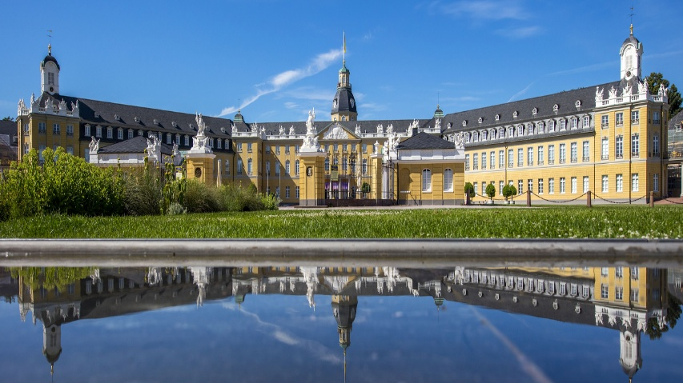
Figure 1. View of the Karlsruhe Palace.

Length
As already explained, it is expected that the submitted abstract should be max. 3-page long and contain first results of the research – not only perspectives. The rest of the text below is simply a place-holder.
Lorem ipsum dolor sit amet, consetetur sadipscing elitr, sed diam nonumy eirmod tempor invidunt ut labore et dolore magna aliquyam erat, sed diam voluptua. At vero eos et accusam et justo duo dolores et ea rebum. Stet clita kasd gubergren, no sea takimata sanctus est Lorem ipsum dolor sit amet. Lorem ipsum dolor sit amet, consetetur sadipscing elitr, sed diam nonumy eirmod tempor invidunt ut labore et dolore magna aliquyam erat, sed diam voluptua. At vero eos et accusam et justo duo dolores et ea rebum. Stet clita kasd gubergren, no sea takimata sanctus est Lorem ipsum dolor sit amet. Lorem ipsum dolor sit amet, consetetur sadipscing elitr, sed diam nonumy eirmod tempor invidunt ut labore et dolore magna aliquyam erat, sed diam voluptua. At vero eos et accusam et justo duo dolores et ea rebum. Stet clita kasd gubergren, no sea takimata sanctus est Lorem ipsum dolor sit amet.

Duis autem vel eum iriure dolor in hendrerit in vulputate velit esse molestie consequat, vel illum dolore eu feugiat nulla facilisis at vero eros et accumsan et iusto odio dignissim qui blandit praesent luptatum zzril delenit augue duis dolore te feugait nulla facilisi. Lorem ipsum dolor sit amet, consectetuer adipiscing elit, sed diam nonummy nibh euismod tincidunt ut laoreet dolore magna aliquam erat volutpat.

Ut wisi enim ad minim veniam, quis nostrud exerci tation ullamcorper suscipit lobortis nisl ut aliquip ex ea commodo consequat. Duis autem vel eum iriure dolor in hendrerit in vulputate velit esse molestie consequat, vel illum dolore eu feugiat nulla facilisis at vero eros et accumsan et iusto odio dignissim qui blandit praesent luptatum zzril delenit augue duis dolore te feugait nulla facilisi. Duis autem vel eum iriure dolor in hendrerit in vulputate velit esse molestie consequat, vel illum dolore eu feugiat nulla facilisis at vero eros et accumsan et iusto odio dignissim qui blandit praesent luptatum zzril delenit augue duis dolore te feugait nulla facilisi.

Nam liber tempor cum soluta nobis eleifend option congue nihil imperdiet doming id quod mazim placerat facer possim assum. Lorem ipsum dolor sit amet, consectetuer adipiscing elit, sed diam nonummy nibh euismod tincidunt ut laoreet dolore magna aliquam erat volutpat. Ut wisi enim ad minim veniam, quis nostrud exerci tation ullamcorper suscipit lobortis nisl ut aliquip ex ea commodo consequat.

At vero eos et accusam et justo duo dolores et ea rebum. Stet clita kasd gubergren, no sea takimata sanctus est Lorem ipsum dolor sit amet. Lorem ipsum dolor sit amet, consetetur sadipscing elitr, sed diam nonumy eirmod tempor invidunt ut labore et dolore magna aliquyam erat, sed diam voluptua. At vero eos et accusam et justo duo dolores et ea rebum. Stet clita kasd gubergren, no sea takimata sanctus est Lorem ipsum dolor sit amet. Lorem ipsum dolor sit amet, consetetur sadipscing elitr, At accusam aliquyam diam diam dolore dolores duo eirmod eos erat, et nonumy sed tempor et et invidunt justo labore Stet clita ea et gubergren, kasd magna no rebum. sanctus sea sed takimata ut vero voluptua. est Lorem ipsum dolor sit amet. Lorem ipsum dolor sit amet, consetetur sadipscing elitr, sed diam nonumy eirmod tempor invidunt ut labore et dolore magna aliquyam erat.

Consetetur sadipscing elitr, sed diam nonumy eirmod tempor invidunt ut labore et dolore magna aliquyam erat, sed diam voluptua. At vero eos et accusam et justo duo dolores et ea rebum. Stet clita kasd gubergren, no sea takimata sanctus est Lorem ipsum dolor sit amet. Lorem ipsum dolor sit amet, consetetur sadipscing elitr, sed diam nonumy eirmod tempor invidunt ut labore et dolore magna aliquyam erat, sed diam voluptua. At vero eos et accusam et justo duo dolores et ea rebum. Stet clita kasd gubergren, no sea takimata sanctus est Lorem ipsum dolor sit amet. Lorem ipsum dolor sit amet, consetetur sadipscing elitr, sed diam nonumy eirmod tempor invidunt ut labore et dolore magna aliquyam erat, sed diam voluptua. At vero eos et accusam et justo duo dolores et ea rebum. Stet clita kasd gubergren, no sea takimata sanctus.

Lorem ipsum dolor sit amet, consetetur sadipscing elitr, sed diam nonumy eirmod tempor invidunt ut labore et dolore magna aliquyam erat, sed diam voluptua. At vero eos et accusam et justo duo dolores et ea rebum. Stet clita kasd gubergren, no sea takimata sanctus est Lorem ipsum dolor sit amet. Lorem ipsum dolor sit amet, consetetur sadipscing elitr, sed diam nonumy eirmod tempor invidunt ut labore et dolore magna aliquyam erat, sed diam voluptua. At vero eos et accusam et justo duo dolores et ea rebum. Stet clita kasd gubergren, no sea takimata sanctus est Lorem ipsum dolor sit amet. Lorem ipsum dolor sit amet, consetetur sadipscing elitr, sed diam nonumy eirmod tempor invidunt ut labore et dolore magna aliquyam erat, sed diam voluptua. At vero eos et accusam et justo duo dolores et ea rebum. Stet clita kasd gubergren, no sea takimata sanctus est Lorem ipsum dolor sit amet.

Duis autem vel eum iriure dolor in hendrerit in vulputate velit esse molestie consequat, vel illum dolore eu feugiat nulla facilisis at vero eros et accumsan et iusto odio dignissim qui blandit praesent luptatum zzril delenit augue duis dolore te feugait nulla facilisi. Lorem ipsum dolor sit amet, consectetuer adipiscing elit, sed diam nonummy nibh euismod tincidunt ut laoreet dolore magna aliquam erat.

References
Literature sources are identified in the text with numbers in square brackets. References to journals [1], books [2], conference proceedings [3] and dissertations [4] are to be formatted as shown below.

[1] Bockhorn, H., Hornung, A., Hornung, U., Schawaller, D.: Kinetic study on the thermal degradation of polypropylene and polyethylene, Journal of Analytical and Applied Pyrolysis, 48(2), 93-109, 1999.
[2] Scheirs, J., Kaminsky, W.: Feedstock recycling and pyrolysis of waste plastics, John Wiley & Sons, Chichester, 2006.
[3] Shimizu, S., Fujisawa, A., Mizuno, O., Kameda, T., Yoshioka, T.: Fermentative hydrogen production from food waste without inocula, AIP Conference Proceedings, Sendai, Japan, 2008.
[4] Tavakkol, S.: Numerical Simulation of Wet Biomass Carbonization in Tubular Reactors, Ph.D. Thesis, Karlsruher Institut für Technologie (KIT), 2021.

